# Homework #1: Testing Windows Server 2016 VM

Name: Jackson Mundy

**(TASK #1: 5 points)** Login to the Windows Server and take a screenshot of the first screen.

**(TASK #2: 5 points)** Show in a screenshot the services that are running.

**(TASK #3: 5 points)** Execute the following queries. Show the results in a screenshot. You must show that the installation is SQL Server 2016.

**(TASK #4: 5 points)** Execute the following query. 1) Show the result in a screenshot. 2) How many departments did you get with the query? You need to answer both questions explicitly.

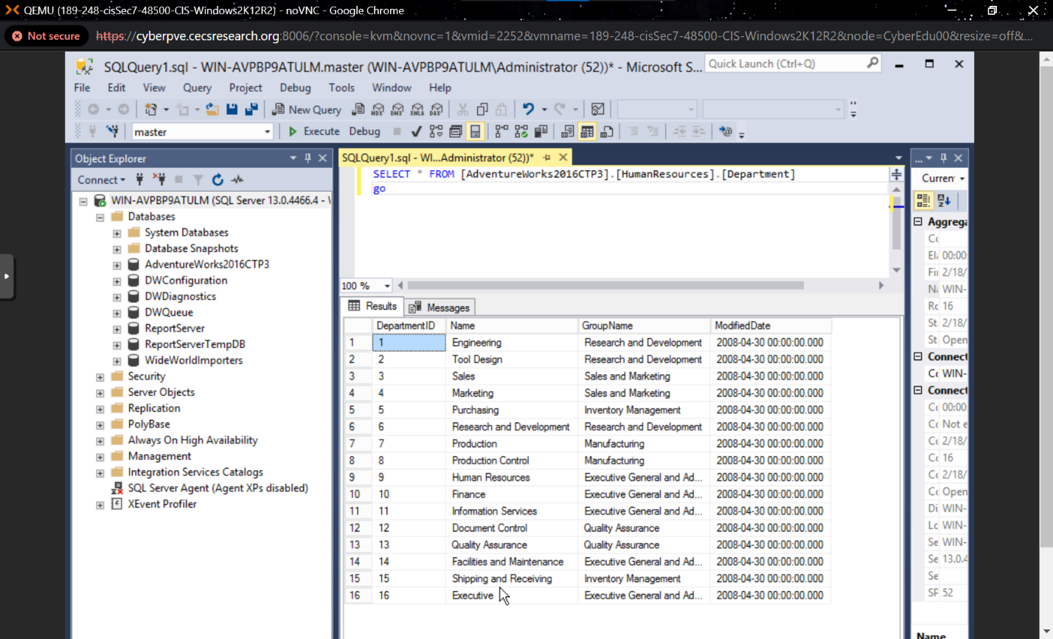

There are 16 departments because of the 16 unique department IDs.